Nome: Eduarda Souza Ribeiro

**CÓDIGO**

**/\***

**Blink**

**Turns an LED on for one second, then off for one second, repeatedly.**

**Most Arduinos have an on-board LED you can control. On the UNO, MEGA and ZERO**

**it is attached to digital pin 13, on MKR1000 on pin 6. LED_BUILTIN is set to**

**the correct LED pin independent of which board is used.**

**If you want to know what pin the on-board LED is connected to on your Arduino**

**model, check the Technical Specs of your board at:**

**https://www.arduino.cc/en/Main/Products**

**modified 8 May 2014**

**by Scott Fitzgerald**

**modified 2 Sep 2016**

**by Arturo Guadalupi**

**modified 8 Sep 2016**

**by Colby Newman**

**This example code is in the public domain.**

**https://www.arduino.cc/en/Tutorial/BuiltInExamples/Blink**

**\*/**

**// the setup function runs once when you press reset or power the board**

**void setup() {**

**// initialize digital pin LED_BUILTIN as an output.**

**pinMode(LED_BUILTIN, OUTPUT);**

**}**

**// the loop function runs over and over again forever**

**void loop() {**

**digitalWrite(LED_BUILTIN, HIGH); // turn the LED on (HIGH is the voltage level)**

**delay(1000); // wait for a second**

**digitalWrite(LED_BUILTIN, LOW); // turn the LED off by making the voltage LOW**

**delay(1000); // wait for a second**

**}**

**CÓDIGO**

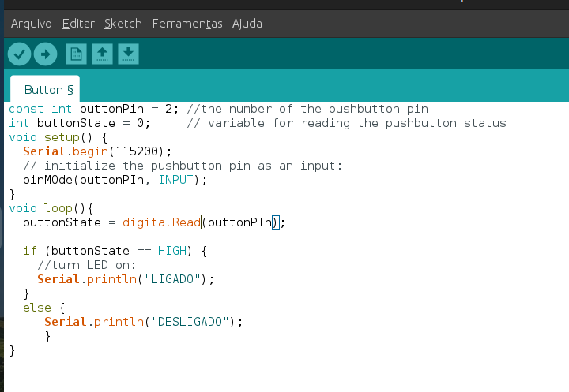

**CÓDIGO**

